

|  |  |  |
| --- | --- | --- |
| **Project Title** | **:** | MAERSK CONTAINER MANAGEMENT SYSTEM |
| **Module Code** | **:** | CT071-3-5-3-DDAC |
| **Intake Code** | **:** | UC3F1701SE |
| **TP number** | **:** | TP038611 |
| **Student Name** | **:** | Marcus Lee Tzyy Min |
| **Lecturer Name** | **:** | DR. KALAI ANAND A/L RATNAM |
| **Hand in Date** | **:** | 13 April 2018 |

# Acknowledgement

Firstly, I would like to extend my appreciation towards my parents for the opportunity and support for my university education in terms of morale support and financial support. I would like to thank Asia Pacific University of Technology and Innovation for having this module, Designing and Developing Application on Cloud too to better understand the applications and deployments of cloud applications. Would like to express my gratitude towards Dr Kalai for his guidance and expertise in the field of cloud computing. His teaching and explanations had made it easier to understand the fundamentals of cloud computing with the various real-life experiences he provided.

Table of Contents

Acknowledgement 2

1.0 Introduction 5

**1.1.** **Project Background** 5

**1.2.** **Objective** 5

**1.3.** **Scope** 5

**1.4.** **Requirement Specification** 5

**1.5.** **Summary of Functions Specifications** 6

2.0 Project Plan 7

3.0 Design 8

3.1 Cloud Architectural Diagram 8

3.2 Modelling 9

3.2.1 Use Case Diagram 9

3.2.2 Use case description 11

3.2.3 Sequence Diagram 17

4.0 Implementation 24

4.1 Deploy on Azure 24

4.2 Application Scaling 27

4.3 Manage Database (PAAS) 29

5.0 Test Plan & Testing Discussion 32

5.1 Unit Testing 32

5.2 Performance 37

6.0 Conclusion 39

References 40

# Introduction

1. **Project Background**

Maersk Line is the global container division founded in 1928 and is the largest operating unit of the A.P. Moller – Maersk Group, a Danish business conglomerate. It has customers through 374 offices in 116 countries, employs approximately 7,000 sea farers and approximately 25,000 land-based people and operates over 600 vessels with a capacity of 2.6 million TEU.

The company wish to support the overall business strategy from an IT perspective that will further business growth and increase organizational flexibility by consolidating all its data centres and server rooms operating worldwide onto a virtualized platform using Microsoft Azure. Maersk is currently changing over its IT setup based on Microsoft Azure, starting with the desktop environment up to container management.

1. **Objective**

To design and develop a Container Management System (CMS) to cater to manage the containers, a solution that reduces overall supply chain costs and an efficient way to manage logistics.

1. **Scope**

To develop the CMS and upload to Microsoft Azure to allow integration and the company to access the system

1. **Requirement Specification**
2. From import, export and transhipment processing to gate operations.
3. To be able to scale the solution to meet the needs of demands during peak seasons.
4. Improves profitability, reduce costs, increases productivity, eradicates errors and optimizes resources to future-proof your cargo handling business for high performance.
5. Assurance & reliability through Failover Management.
6. Accurately allocates inbound containers to yard locations and plan outbound containers to individual haulier vehicles, delivering an exceptional level of automation and removing human error.
7. Manage your entire booking process from schedule search to booking confirmation.
8. **Summary of Functions Specifications**

The main function of the CMS system will include 2 different logins, admin and agent. Admin of the shipping provider will be able to define schedule, register/create agents and view the different details. Agent can register customer, register the type of goods they are going to send, book the schedule and after booking receive confirmation.

# 2.0 Project Plan

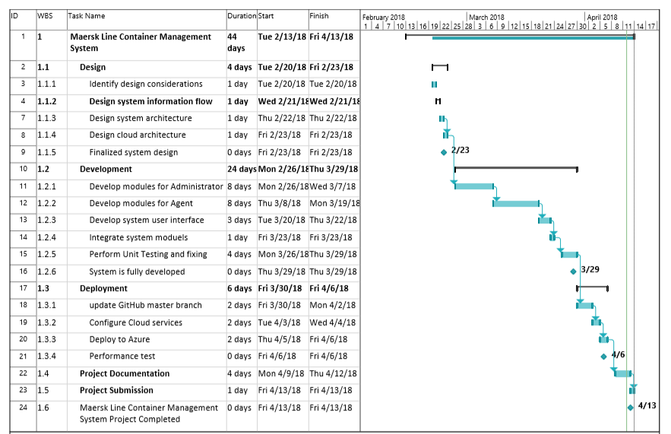

# 3.0 Design

## 3.1 Cloud Architectural Diagram



The diagram above is the cloud architecture used for deploying the application to the Azure cloud platform. Maersk Line is looking to create a container management system to manage the containers, a solution that reduces overall supply chain costs and an efficient way to manage logistics. Because the application was written using PHP and MySQL, a MySQL server was provisioned instead of the standard SQL server. The total estimated cost incurred by implementing the architecture above is shown in the table below:

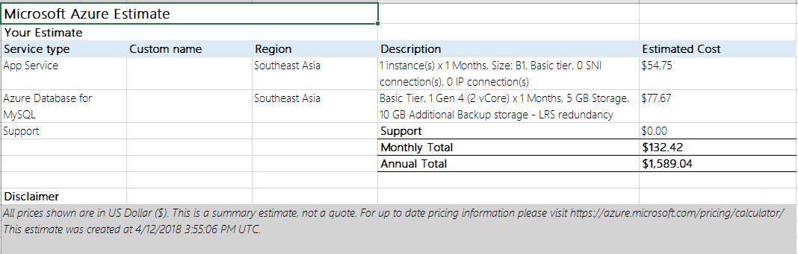

## 3.2 Modelling

### 3.2.1 Use Case Diagram





### 3.2.2 Use case description

|  |  |
| --- | --- |
| Use Case | Login |
| Actor | Admin, Agent |
| Summary | Admin and agent log in using their username and password |
| Precondition | None |
| Description of main sequence | 1. Open the main page 2. Enter credentials 3. Login 4. Enter to the system |
| Post condition | Logged in to the system as the respective privilege |

|  |  |
| --- | --- |
| Use Case | View Schedule |
| Actor | Admin |
| Summary | To view all previously created schedule in the system |
| Precondition | Login as admin, a schedule is created |
| Description of main sequence | 1. Login to the system 2. Click on the schedule tab at the navigation bar 3. All schedule will be displayed in the page |
| Post condition | The schedule will be displayed on the screen |
| Use Case | Create Schedule |
| Actor | Admin |
| Summary | Admin to create a schedule for agents to book schedule |
| Precondition | Login to the system as an admin |
| Description of main sequence | 1. Login into the system as an admin 2. Click the shipping button at the navigation bar 3. Enter the necessary Details 4. Click Create button at the bottom of page 5. Schedule created |
| Post condition | Schedule created in the system database |

|  |  |
| --- | --- |
| Use Case | View Agent |
| Actor | Admin, agent |
| Summary | To view all the agent that are in the system |
| Precondition | Login to the system |
| Description of main sequence | 1. Login to the system as an admin 2. Click the “agent” button at the navigation bar 3. The agents will be displayed in the screen |
| Post condition | Agent displayed on the screen |

|  |  |
| --- | --- |
| Use Case | Register Agent |
| Actor | Admin |
| Summary | Admin to be able to create an agent for the container management system |
| Precondition | Login to the system as an Admin |
| Description of main sequence | 1. Login to the system as an admin 2. Click the “agent” button at the navigation bar 3. Click on the Create button at the bottom of the page 4. Enter the details required 5. Click on the “Submit” button 6. Agent is created for the system |
| Post condition | Agent is created in the system database |

|  |  |
| --- | --- |
| Use Case | View Staff |
| Actor | Admin |
| Summary | To view all the staff that are in the system |
| Precondition | Login as admin |
| Description of main sequence | 1. Login to the system as an admin 2. Click the “staff” button at the navigation bar 3. The staff will be displayed in the screen |
| Post condition | All staff displayed on the screen in table form |

|  |  |
| --- | --- |
| Use Case | Register Staff |
| Actor | Admin |
| Summary | Admin to be able to create an staff for the container management system |
| Precondition | Login to the system as an Admin |
| Description of main sequence | 1. Login to the system as an admin 2. Click the “staff” button at the navigation bar 3. Click on the Create button at the bottom of the page 4. Enter the details required 5. Click on the “Submit” button 6. Staff is created for the system |
| Post condition | The staff is created in the system database |

|  |  |
| --- | --- |
| Use Case | View customer |
| Actor | Agent |
| Summary | To view all the customer that are in the system |
| Precondition | Login as agent |
| Description of main sequence | 1. Login to the system as an agent 2. Click the “customer” button at the navigation bar 3. The customer will be displayed in the screen |
| Post condition | All customers will be displayed on the screen in table form |

|  |  |
| --- | --- |
| Use Case | Create customer |
| Actor | Agent |
| Summary | Agent to be able to create a new customer for the container management system |
| Precondition | Login to the system as an Agent |
| Description of main sequence | 1. Login to the system as an agent 2. Click the “customer” button at the navigation bar 3. Click on the Create button at the bottom of the page 4. Enter the details required 5. Click on the “Submit” button 6. Customer is created for the system |
| Post condition | The customer is created in the system database |

|  |  |
| --- | --- |
| Use Case | View cargo |
| Actor | Agent |
| Summary | To view all the customer that are in the system |
| Precondition | Login as agent |
| Description of main sequence | 1. Login to the system as an agent 2. Click the “cargo” button at the navigation bar 3. The cargo will be displayed in the screen |
| Post condition | All cargo will be displayed on the screen in table form |

|  |  |
| --- | --- |
| Use Case | Create cargo |
| Actor | Agent |
| Summary | Agent to be able to create a new cargo for the container management system |
| Precondition | Login to the system as an Agent |
| Description of main sequence | 1. Login to the system as an agent 2. Click the “cargo” button at the navigation bar 3. Click on the Create button at the bottom of the page 4. Enter the details required 5. Click on the “Submit” button 6. Cargo is created for the system |
| Post condition | The cargo is created in the system database |

|  |  |
| --- | --- |
| Use Case | View warehouse |
| Actor | Agent |
| Summary | To view all the customer that are in the system |
| Precondition | Login as agent |
| Description of main sequence | 1. Login to the system as an agent 2. Click the “warehouse” button at the navigation bar 3. The warehouse list will be displayed in the screen |
| Post condition | All the warehouses will be displayed on the screen in table form |
| Use Case | Create warehouse |
| Actor | Agent |
| Summary | Agent to be able to register a new warehouse r the container management system |
| Precondition | Login to the system as an Agent |
| Description of main sequence | 1. Login to the system as an agent 2. Click the “warehouse” button at the navigation bar 3. Click on the Create button at the bottom of the page 4. Enter the details required 5. Click on the “Submit” button 6. Warehouse is created for the system |
| Post condition | The warehouse is created in the system database |

### 

### 3.2.3 Sequence Diagram



























# 4.0 Implementation

## 4.1 Deploy on Azure

The entire system is firstly published into GitHub and then pushed into Microsoft Azure for automatic deployment. This will allow any changes that will be made into GitHub and will also be deployed directly into the Azure server.

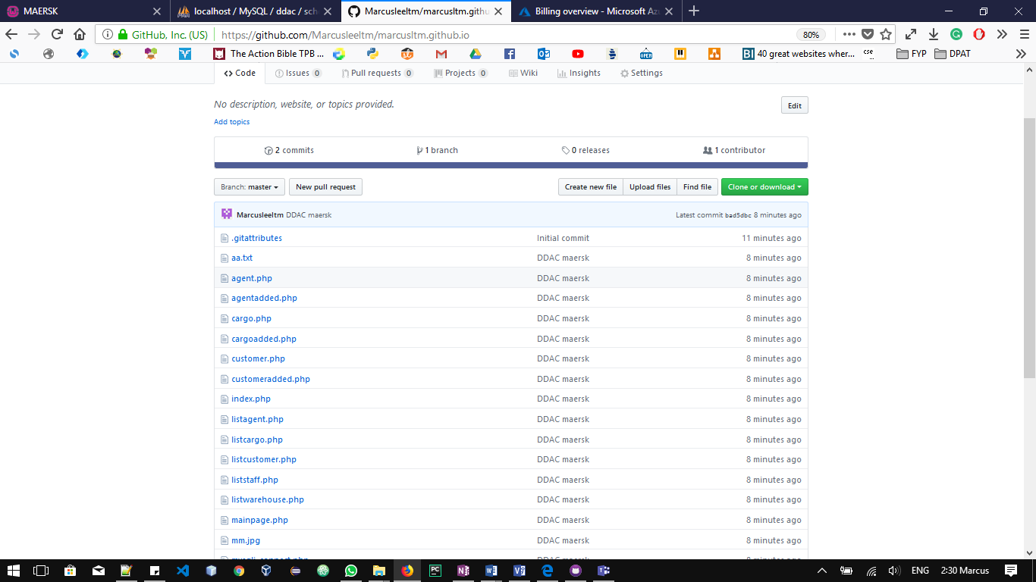

The appropriate Web application service is selected on Azure. In the case of this deployment and development of the container management system, the most suitable will be a web app + ‘SQL since the application uses PHP and MySQL to develop.

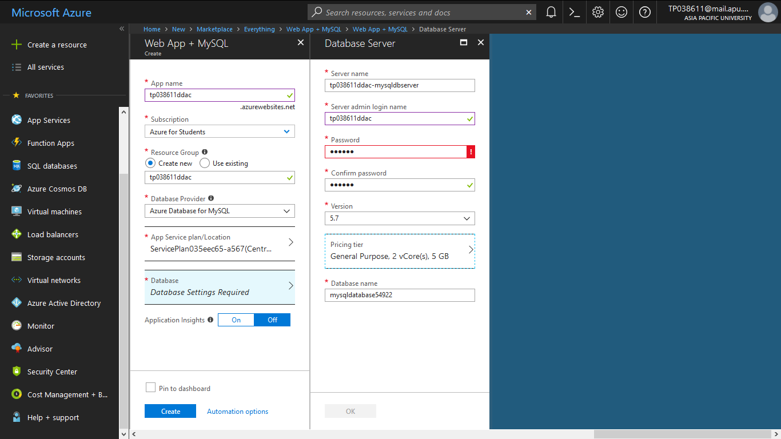

Wait for a few minutes as Azure submit the deployment for Web App + SQL and create the platform for the Container Management system. While waiting MySQL server can be upload into Azure using the help of a software MySQL Workbench. The hostname, username and password could be taken from Azure portal in the database service. After creating the connection with Azure server, the MySQL query then can be uploaded into the platform as well.

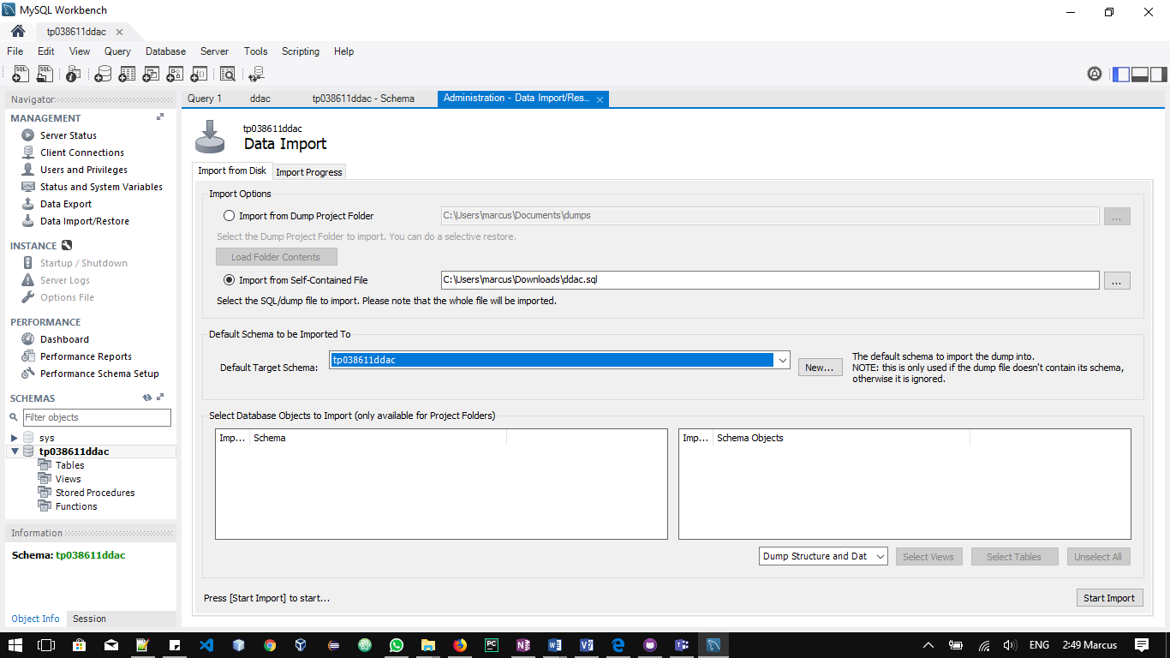

After completing the both the Azure Web app service and the MySQL server merging, the system can be said to be successfully deployed into the cloud and could be found in the following link:

https://tp038611ddac.azurewebsites.net/mainpage.php

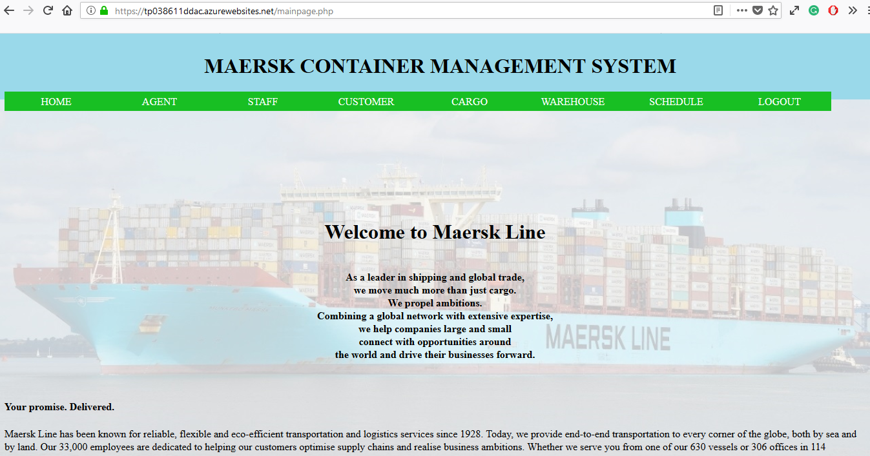

## 4.2 Application Scaling

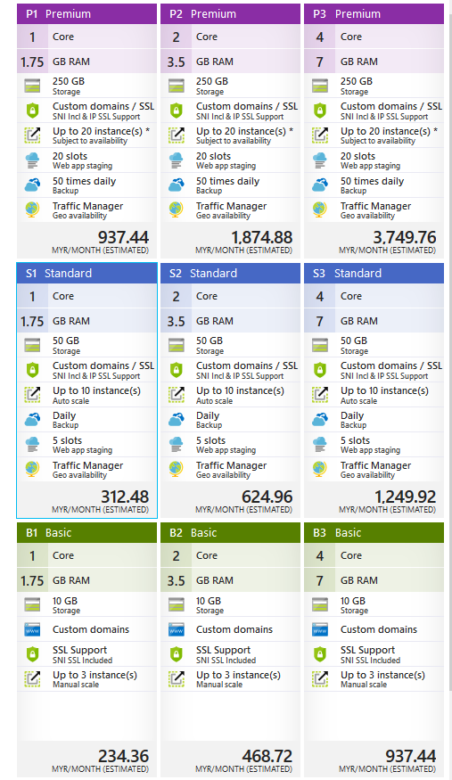

According to (Azure.microsoft.com, 2018), Azure cloud environment provides the web service for auto scaling which the resource can be dynamically allocated based on the needs to match with performance requirement. This is particularly important when Maersk’s Container Management System increase in workload, more resource is needed to maintain the desired performance levels. The scaling to add extra resource is nothing to be worried about as during high peak more resource can be allocated automatically and deallocated when no longer needed. This can help Maersk to minimize the operation cost.

## 4.3 Manage Database (PAAS)

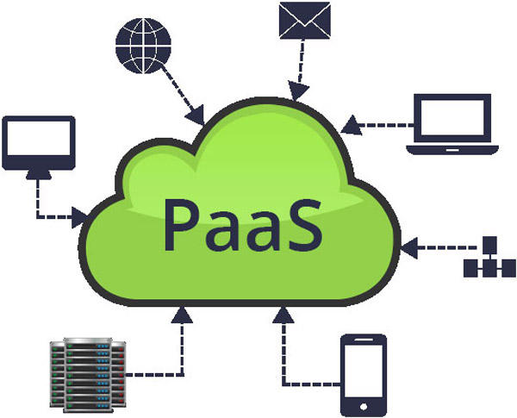

Platform as a Service (PaaS) is a cloud platform service. Platform as a service (PaaS) is a complete development and deployment environment in the cloud, with resources that enable you to deliver everything from simple cloud-based apps to sophisticated, cloud-enabled enterprise applications. You purchase the resources you need from a cloud service provider on a pay-as-you-go basis and access them over a secure Internet connection. (Azure.microsoft.com, 2018)

It is used for applications and other development, while providing cloud components to software. Developers can use this framework and build upon to develop or customize application. (Apprenda,2018) PaaS can be delivered through public, private, or hybrid clouds. With a public cloud PaaS, the customer controls software deployment while the cloud provider delivers all the major IT components needed to host the applications, including servers, storage systems, networks, operating systems, and databases. (Violino, 2018)

A PaaS provider hosts the hardware and software on its own infrastructure. As a result, PaaS frees users from having to install in-house hardware and software to develop or run a new application. As with most cloud services, PaaS is built on virtualization technology. (SearchCloudComputing, 2018)

Having a platform for the creation of on-demand applications or software delivered over the web bring many different benefits to different parties including the developer, the business and the company. It makes the development, testing and deployment of applications quick simple and cost-effective since the development team can try different configuration, multiple machines and different locations to run test and access performance.

Beside it will reduce the need to expend effort on the maintenance and choice system, giving business and companies to focus more on their core business rather than the technicalities of the development processes. Hence increasing and empowering visionaries and give internal entrepreneurship a boost since the business had set aside a specific sum under the cloud budget.

Other benefits include staying up to date with the latest deployment the soonest, maximizing uptime as vendors have the tools and experience to handle unplanned risk that occurs. Scalability is also very simple and easy with the help of PaaS where the system can be scaled according to the given size of business. Throughout the years, security had been improving and so many vendors offer a great deal of security for your system.

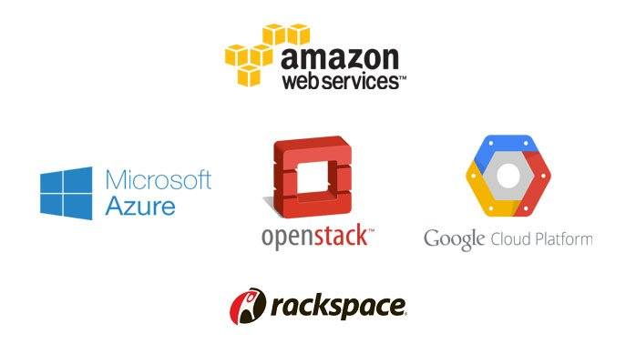

There are many different cloud providers in the market, with the main providers from tech giants such as Google, Amazon and Microsoft. Amazon cloud services is known as Amazon Web Services (AWS), Microsoft call its cloud service Microsoft Azure and Google’s cloud services is known as Google Cloud Platform.

AWS, Microsoft Azure and Google Cloud Platform offer largely similar basic capabilities around flexible compute, storage and networking. They all share the common elements of a public cloud: self-service and instant provisioning, autoscaling, plus security, compliance and identity management features.

# 5.0 Test Plan & Testing Discussion

## 5.1 Unit Testing

|  |  |  |  |  |  |
| --- | --- | --- | --- | --- | --- |
| Test ID | Test Case | Test Case Description | Expected Result | Actual Result | Status |
| T1 | Login | 1. Enter the credentials as an Admin 2. Click on the login “button” 3. Navigate to the main page with admin privileges | Successfully login to the system as an admin | Successfully login to the system as an admin | Pass |
| T2 | Login | 1. Enter the credentials as an agent 2. Click on the login “button” 3. Navigate to the main page with agent privileges | Successfully login to the system as an agent | Successfully login to the system as an agent | Pass |
| ADMIN | | | | | |
| TAD1 | View Agent | 1. Login as an admin 2. Click on agent at the navigation bar 3. List of agents will be displayed in a table in the screen | The table of agents is displayed | The table of agents is displayed | Pass |
| TAD2 | Register Agent | 1. Login as an admin 2. Click on agent at the navigation bar 3. Click on create button 4. Enter the details necessary 5. Click on the submit button 6. Navigate back to the agent page 7. Agent will be added into the table | Agent is added to the database | Agent is added to the database | Pass |
| TAD3 | View Staff | 1. Login as an admin 2. Click on staff at the navigation bar 3. List of staff will be displayed in a table in the screen | The table of staff is displayed | The table of staff is displayed | Pass |
| TAD4 | Create Staff | 1. Login as an admin 2. Click on staff at the navigation bar 3. Click on create button 4. Enter the details necessary 5. Click on the submit button 6. Navigate back to the staff page 7. Staff will be added into the table | Staff is added to the database | Staff is added to the database | Pass |
| TAD5 | View Schedule | 1. Login as an admin 2. Click on schedule at the navigation bar 3. List of schedules will be displayed in a table in the screen | The table of schedule is displayed | The table of schedule is displayed | Pass |
| TAD6 | Create Schedule | 1. Login as an admin 2. Click on schedule at the navigation bar 3. Click on create button 4. Enter the details necessary 5. Click on the submit button 6. Navigate back to the schedule page 7. Schedule will be added into the table | Schedule is added to the database | Schedule is added to the database | Pass |
| AGENT | | | | | |
| TAG1 | View Customer | 1. Login as an agent 2. Click on customer at the navigation bar 3. List of customers will be displayed in a table in the screen | The table of customer is displayed | The table of customer is displayed | Pass |
| TAG2 | Create Customer | 1. Login as an agent 2. Click on customer at the navigation bar 3. Click on create button 4. Enter the details necessary 5. Click on the submit button 6. Navigate back to the customer page 7. Customer will be added into the table | customer is added to the database | customer is added to the database | Pass |
| TAG3 | View Cargo | 1. Login as an agent 2. Click on cargo at the navigation bar 3. List of cargo will be displayed in a table in the screen | The table of cargo is displayed | The table of cargo is displayed | Pass |
| TAG4 | Create Cargo | 1. Login as an agent 2. Click on cargo at the navigation bar 3. Click on create button 4. Enter the details necessary 5. Click on the submit button 6. Navigate back to the cargo page 7. Cargo will be added into the table | New cargo is added to the database | New cargo is added to the database | Pass |
| TAG5 | View Warehouse | 1. Login as an agent 2. Click on warehouse at the navigation bar 3. List of warehouses will be displayed in a table in the screen | The table of warehouse is displayed | The table of warehouse is displayed | Pass |
| TAG6 | Create Warehouse | 1. Login as an agent 2. Click on warehouse at the navigation bar 3. Click on create button 4. Enter the details necessary 5. Click on the submit button 6. Navigate back to the warehouse page 7. Warehouse will be added into the table | warehouse is added to the database | warehouse is added to the database | Pass |
| TAG7 | View Schedule | 1. Login as an agent 2. Click on schedule at the navigation bar 3. List of schedules will be displayed in a table in the screen | The table of schedule is displayed | The table of schedule is displayed | Pass |

## 5.2 Performance

The performance analysis testing for the CMS can be achieve through conducting the performance test on server with simulation of user visiting the server. This is a feature of Azure Portal and the testing here will be conducted based on three different standard plans and the number of user load within the given period.

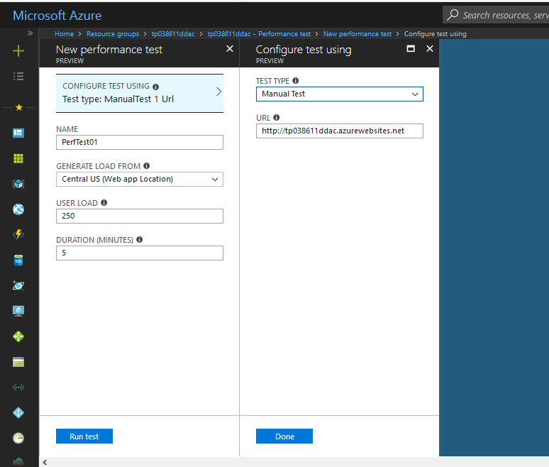

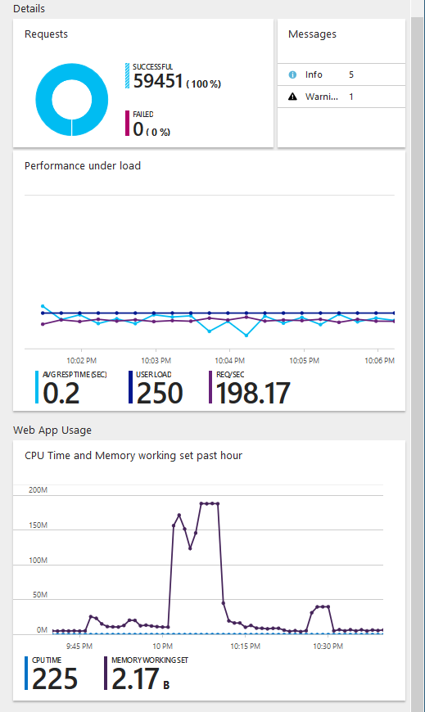

From the report, it shows that the system will be stable, and performance will still be able to maintain even when 250 users access the system concurrently over the course of 5 minutes. It is acceptable, and the business can continue to run smoothly without to worry about downtime or the possible of system crash due to overloading of user acting upon the system concurrently.

# 6.0 Conclusion

In conclusion, the development of a container management system that is cloud based had been an educative and changeling journey. Developing the web application and then to deploy it onto Microsoft Azure required careful calculations and planning as it provides many different options to customize the cloud system as per required. Microsoft Azure is a fundamental and needful knowledge when it comes to cloud computing. This assignment had given me the opportunity to practice new and relevant skill that will be valuable in the cloud technology age where everything is to be done on cloud. Cloud computing is a great euphemism for centralization of computer services under one server.

# References

1. Apprenda. (2018). *IaaS, PaaS, SaaS (Explained and Compared)*. [online] Available at: https://apprenda.com/library/paas/iaas-paas-saas-explained-compared/ [Accessed 6 Apr. 2018].
2. Azure.microsoft.com. (2018). *What is PaaS? Platform as a Service | Microsoft Azure*. [online] Available at: https://azure.microsoft.com/en-us/overview/what-is-paas/ [Accessed 5 Apr. 2018].
3. SearchCloudComputing. (2018). *What is Platform as a Service (PaaS)? - Definition from WhatIs.com*. [online] Available at: https://searchcloudcomputing.techtarget.com/definition/Platform-as-a-Service-PaaS [Accessed 4 Apr. 2018].
4. Violino, B. (2018). *What is PaaS? Software development in the cloud explained*. [online] InfoWorld. Available at: https://www.infoworld.com/article/3223434/paas/what-is-paas-software-development-in-the-cloud.html [Accessed 13 Apr. 2018].